Maternity leave and return to work guidance

# Telling people

You’re pregnant. Congratulations! Whilst making the decision to tell your colleagues is a personal choice you must notify your Lead Employer (NHS GGC) HR Department, Training Programme Director, clinical supervising consultant and Medical Staffing at your current rotation Health Board as soon as is reasonably practical and no later than the end of the 15th week before the expected week of childbirth (EWC).

In some cases, earlier notification may be beneficial to identify and manage risks within the workplace particularly if you are struggling with early pregnancy symptoms.

[Pregnancy - FAQs - Scotland Deanery (nhs.scot)](https://www.scotlanddeanery.nhs.scot/trainee-information/pregnancy-parental-leave-and-breastfeeding-as-a-doctor-in-training/pregnancy-faqs/)

As your employing board you will need to contact HR in NHS GGC as well as your current placement Health board if working out with GGC.

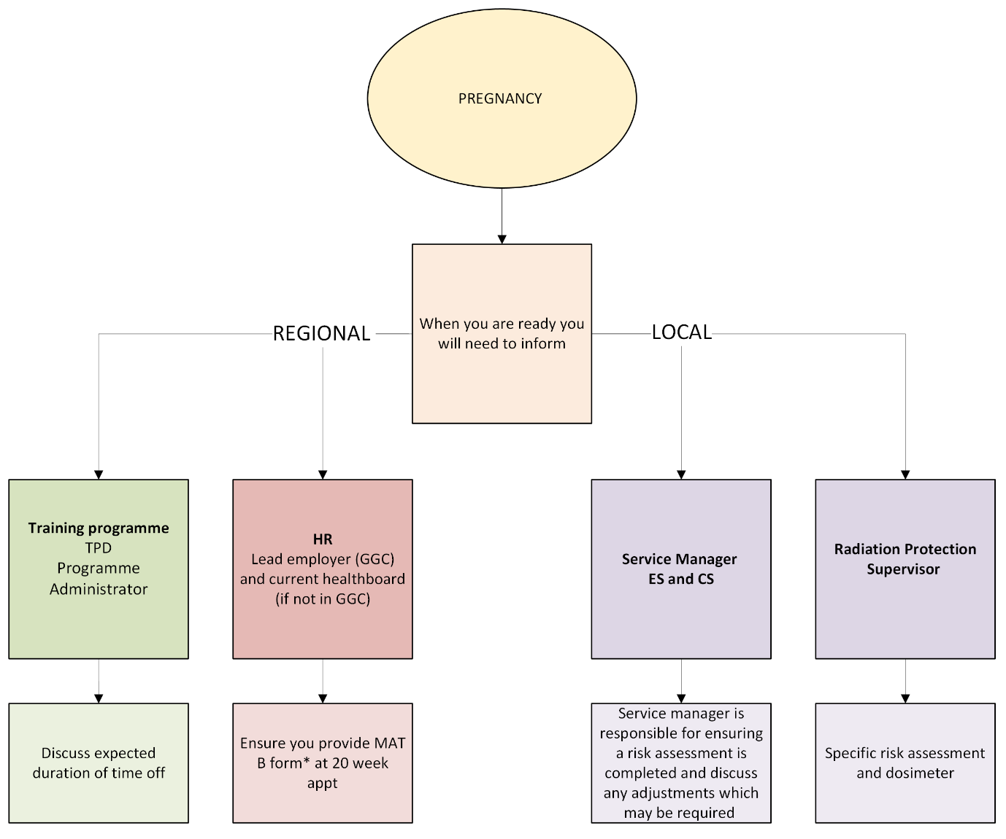

## **About the Maternity Certificate (form MAT B1)**

The Maternity Certificate (MAT B1) enables a pregnant woman to claim statutory Maternity Pay (SMP) from her employer.

The certificate:

* verifies the pregnancy
* confirms the date of the expected week of confinement (EWC)
* confirms the actual date of birth when completed after confinement
* can be issued by the doctor or midwife providing clinical care not more than 20 weeks before the EWC, ie at 20-week appt

[Family Leave and Work Life Balance - NHSGGC](https://www.nhsggc.scot/staff-recruitment/hrconnect/policies-and-staff-governance/polices/family-leave-and-work-life-balance/)

[HR Support & Advice Unit - NHSGGC](https://www.nhsggc.scot/staff-recruitment/hrconnect/contact-hr-support-advice-unit/)

[Policies and Guidance - NHSGGC](https://www.nhsggc.scot/staff-recruitment/hrconnect/doctors-and-dentists-in-training-junior-doctors/policies-and-guidance/)

# Time off for appointments

Pregnant trainees are entitled to paid time off to attend antenatal care.

There is also a legal requirement for partners to be able to attend two appointments and requests to attend additional appointments should be accepted where the service can allow to do so.

# Occupational risks

A risk assessment should be performed as soon as possible by the service manager after being informed that a trainee is pregnant.

An example of risk assessment is below

<https://www.nhsggc.org.uk/media/235687/matriskassess.docx>

It is essential to consider all the risks and identify mitigating actions. There are risks which will be applicable to all staff but some which are especially relevant to T&O trainees and these need to be considered appropriately.

During risk assessment specific consideration should be given to:

* **Physical demands** (moving and handling, on call shifts, ability to perform manipulations and procedures, long durations of standing)
* **Specific hazards** (radiation, cement, iodine, high risk cases such a blood borne infections)
* **General conditions** (lone operating, OOH operating/on calls, adequate rest)
* **Mental demands** of the job

If the risk cannot be removed, then the department must either:

a) Adjust working conditions or hours

b) Offer suitable alternative work (on same pay)

c) Provide paid leave

If the trainee changes host trust during pregnancy then a further risk assessment is required based on the new position, rota pattern, premises etc.

# Radiation

There is no legal obligation to use radiation in pregnancy. Should a trainee wish to continue using radiation the IRMER radiation officer for the host trust should be contacted. A radiation dosimeter should be provided and monitored with a maximum dose exposure of 1mSv. The radiation badge should be worn at the foetal level inside the lead gown. Double lead gowns (0.5mm lead) should be worn and trainees should stand 2m away from the radiation source.

You are encouraged to inform your local Radiation Protection Supervisor of your pregnancy so that a specific risk assessment be carried out and any additional control measures and dosimetry arrangements can be put in place.

The BOA are currently reviewing guidance ad and any recommendations relating to the thickness of lead gown recommended for wearing while operating during pregnancy. Please check website for updates

[Risk Exposure (boa.ac.uk)](https://www.boa.ac.uk/careers-in-t-o/parenthood-orthopaedics/pregnancy/risk-exposure.html)

# Maternity leave

If you have 12 months continuous service with one or more NHS employer at the beginning of the 11th week before the expected week of childbirth (EWC), and you have notified your intention to return to work with the NHS, you are entitled to:

* 8 weeks' full pay, less any Statutory Maternity Pay (SMP) or Maternity Allowance (MA).
* 18 weeks' half pay plus any SMP or MA (providing the total does not exceed full pay).
* 13 weeks' SMP or MA.
* 13 weeks’ unpaid leave.

NES has a great resource to guide you through the process of maternity leave application as well as keep in touch (KIT) days.

[Maternity leave | Hub (nes.digital)](https://hub.nes.digital/help-me-with/hr-related/maternity-leave/)

[Parental Leave - FAQs - Scotland Deanery (nhs.scot)](https://www.scotlanddeanery.nhs.scot/trainee-information/pregnancy-parental-leave-and-breastfeeding-as-a-doctor-in-training/parental-leave-faqs/)

[Leave and Pay (boa.ac.uk)](https://www.boa.ac.uk/careers-in-t-o/parenthood-orthopaedics/maternity-leave-and-pay.html#:~:text=Maternity%20and%20Adoption%20Pay&text=18%20weeks%27%20half%20pay%20plus,does%20not%20exceed%20full%20pay).)

# Information for Supervisors

Time out for parents raising a family should not be seen as a barrier to progression for surgeons. Having the right support in place significantly contributes to retention within the surgical workforce. The BOA believe that it is important for clear expectations to be set for both employer and employee from the start of pregnancy through to return to work and for all surgeons taking parental leave. Those responsible should be well informed and able to support the surgeon throughout.

This document sets out these expectations: <https://www.boa.ac.uk/asset/AA358521-09D1-479D-A3873A5EC40E6E98/>

There are resources on BOA website which you may find useful should you find yourself supporting a trainee through, pregnancy, infertility, miscarriage or child loss. [Pregnancy (boa.ac.uk)](https://www.boa.ac.uk/careers-in-t-o/parenthood-orthopaedics/pregnancy.html)

This BOA Guide provides information on how to support Trainees - <https://www.boa.ac.uk/asset/CA9B2CF3-7F8A-4E12-A4DA8784934B181A/>

# Tips from our trainees

Below is information collated from speaking to trainees in the region who have experienced pregnancy, miscarriage, maternity leave, return to work and parenthood during training.

### **During Pregnancy**

* **Compression Stockings:** These are a worthwhile investment for your comfort and health. Fainting can become an issue during pregnancy and some find these helpful to reduce this. If you do feel faint during a case tell your supervisor and/or scrub staff, you may find descrubbing for a drink, moving around or having a stool nearby helpful.
* **Protective Clothing:** Use double lead, skirt, and tabard gown (this guidance may be updated).
* **Seek Expert Advice:** Consulting with Health Physics or a Radiation Protection Supervisor can be very beneficial.
* **Manual Handling:** Be mindful of relaxin, which can make joints less stable and increase the risk of musculoskeletal injury. It's not just the bump getting in the way—don't overexert yourself.
* **Nutrition:** Make sure to eat and drink regularly.
* **Subspecialty Considerations:** Availability of SFA/SHO second assistant, remember that some subspecialties may be less physically demanding but could involve more radiation exposure.
* **Patient Handling:** Manipulations can be challenging, especially with patients who may be combative under sedation.
* **On-Call Discussions:** Have open discussions about expectations with your supervisor and colleagues when on call. Can you work alone, might you need help with those periprosthetic hip reductions?
* **Needlestick Injuries:** Be aware of the risks of blood-borne viruses (BBV).
* **Support from Nursing Staff:** Nursing staff are excellent allies—don’t hesitate to let them know if you’re struggling.
* **Flexibility:** You can choose to stop on-calls or night shifts whenever you feel you need to. Some trainees who had difficult early pregnancy symptoms took some time off on call duties during first trimester and restarted in the second. However, as pregnancy progresses the physicality of our work becomes more challenging. Our trainees suggest stopping on call duties and out of hours during the third trimester (>28 weeks). This is an arbitrary number, so do not feel obliged to stick to it, every person is different, but some trainees have found it helpful to know that other colleagues have done this before them, and it is wholly accepted by all parties involved. Don’t feel obliged to push through, studies show that surgical registrars have a significantly higher rate of pre-term delivery and miscarriage compared to the general population. Your health and wellbeing are paramount.
* **Miscarriage:** The loss of a pregnancy is an emotional and often physically difficult time. You are entitled to sick leave and should take time to recover without pressure to return to work until you are ready. The Scottish pregnancy survey revealed that most colleagues felt that up to 2 weeks leave would be appropriate following a miscarriage – however, most took no leave and the average leave taken was just 2.5 days. There is no obligation to inform anyone if you are not comfortable to do so. However, consider whether you would like to inform your TPD, AES and rota master to support you during this time and in your return to work thereafter.

### **Maternity Leave**

* **Inform Your Employers:** Notify your current placement board (NHS GGC, NHS forth Valley, NHS Ayrshire and Arran etc) about your maternity leave plans. Speak to TPD who will assist with process for informing the deanery and completing relevant OOP forms.
* **Medical Staffing and HR:** You will need to inform medical staffing of your planned Maternity leave start date. Medical staffing then apply for the mat leave on your behalf to HR and you would receive confirmation letter from HR Support and Advice Unit. During these discussions, they will ask how long you intend to take for maternity leave. Note that payments can be spread equally over 9 or 12 months if you’d prefer, and it is generally easier to shorten the leave than to extend it. If you'd like to extend the duration of maternity leave, you need to give medical staffing a minimum of 28 days' notice. Of course, you also need to inform the Deanery and TPD. Do give as much notice as you possibly can.
* **Declare End Date:** Inform your TPD, HR, and line manager of your intended end date for maternity leave.
* **Payroll Breakdown:** Speak to payroll for a detailed breakdown of your maternity pay.
* **Payment Clarity:** Maternity leave payments can be confusing. If you are unsure, ask the BMA to review them.
* **Membership Considerations:** Organizations such as BOA, your defense union, GMC, and your royal college offer reduced rates or considerations for maternity leave. Your defense union may pause your membership, and you do not have to pay JCST for ISCP for the year.
* **Second Job Caution:** Be cautious about working a second job, even private assisting, as it can invalidate your maternity pay and breach your maternity pay contract. There are specific rules surrounding second jobs, but generally, you can continue a job you had with another employer before your maternity leave.
* **Accrued Leave:** At the end of your maternity leave, you will have accrued your normal leave allowance plus public holidays. For example, 52 weeks of maternity leave + 32 days of annual leave + 8/10 public holidays can result in about 13/14 months off if you take the full 1yr duration.

### **Return to Work Process**

* **Return to Work Date:** JCST will recalculate your CCT date based on your return to work date.
* **Evidence Submission:** Provide evidence of your return to the program and inform payroll of your return to work.
* **ARCP:** It is recommended to complete a return to program reflection and a summary of your activities (if any) during leave, including updates on SOAR.
* **Study Leave:** You are not eligible for study leave during maternity leave.

### **KIT Days**

Keep in Touch (KIT) days are paid at an unbanded day rate. They are designed to help ease your transition back to work through various activities, including:

* Attending clinics or theatre
* Sorting out passwords and mandatory training or inductions
* Participating in courses and conferences
* Engaging in regional teaching
* Reading and other work-related tasks

**Usage of KIT Days:**

* **Timing:** You can use KIT days at any time during your maternity leave (not during your accrued leave).
* **Paid Portion:** If you use KIT days during the paid portion of your maternity leave, you receive a day or half-day in lieu.
* **Unpaid Portion:** If you use them during the unpaid portion of your maternity leave, pay will be either the pay due for that day at your normal rate OR the weeks' worth of statutory maternity pay, whichever is higher. *Top tip:* if you can, consider grouping KIT days, for example, take 2 in the same week, so that it is more "worthwhile" losing your week's SMP pay.
* **Annual leave Portion:** At the end of Maternity Leave once your ‘annual leave’ period starts, you cannot take KIT days anymore. The department you are in might accept for you to go into work and then take a day of annual leave later, once you are formally back at work. However, this must be agreed beforehand as it is not normally the policy.
* **Flexibility:** KIT days can be scheduled at any time of day, including weekends, which is particularly useful for arranging childcare.

**Breastfeeding**

A risk assessment must be carried out for any trainee who is breastfeeding and facilities must be provided and they should be supported to find

* Appropriate break times
* Adequate refrigerated storage (not shared facility with lunches)
* A private space (not a toilet, bathroom, relatives room, or located a significant distance from the ward)

A flexible approach to on call should be discussed in advance as part of planning the return to work.

QE have a breastfeeding room in the atrium (key available from reception)

### **Going Back to Work**

* **Setting Your Return Date:** Inform HR of your return to work date. It's easy to plan for an earlier return, but challenging to extend your leave later, so take as much time as you need initially.
* **Department Assignment:** Ideally, return to a familiar department. Arrange a rotation planning meeting as early as possible.
* **Post-Return Meetings:** Plan a meeting with your supervisor or TPD after your return to work to discuss how things are going
* **Breastfeeding Considerations:** Determine whether you will need accommodations for breastfeeding upon your return.
* **Sleep Deprivation:** Be prepared for the challenges of sleep deprivation.
* **Childcare Arrangements:** Plan your rota as far in advance as possible. Be ready for short notice absences if your child is unwell. Communicate with the on-call reg/SHO if you need to leave to pick up your child from nursery. Extra planning is required for night shifts, which may involve coordination with your partner or childcare.
* **Skill Refreshment:** Consider attending a cadaveric workshop to refresh your skills. Online courses, webinars, ORUK, AO trauma basics, and regional teaching recordings can also be helpful.
* **Department Awareness:** Ensure your department is aware of your return.

# Recommended Resources

* **BOA Return to Work Event:** Consider attending the BOA return to work online event, which is beneficial for anyone returning after being out of the program for any reason.
* **‘Return to work following parental leave’ workshops:** previously by NHS Lothian which are open to trainees across Scotland.
* **Peer Support:** Chat with other trainees who have been on maternity leave for practical advice and support.
* **Miscarriage support** [Miscarriage information and support | Tommy's](https://www.tommys.org/baby-loss-support/miscarriage-information-and-support)
* **Shared parental leave** You and your partner may be able to get Shared Parental Leave (SPL) and Statutory Shared Parental Pay (ShPP) if you’re having a baby, using a surrogate to have a baby or adopting a child check government website for further details [Shared Parental Leave and Pay: How it works - GOV.UK (www.gov.uk)](https://www.gov.uk/shared-parental-leave-and-pay) NHS Scotland Workforce resources: [Shared Maternity and Shared Adoption Policy Guide for Employees | NHS Scotland](https://workforce.nhs.scot/supporting-documents/guide/shared-maternity-and-shared-adoption-policy-guide-for-employees/)
* **Unpaid Parental Leave:** Be aware of unpaid parental leave, which is separate from maternity/paternity leave and shared parental leave. You are entitled to 18 weeks for each child that you can take until they turn 18. The NHS pays for the first 4 weeks (though this may not be common with every employer), and it can be taken in 4-week blocks. This leave needs to be arranged with your service and can be used by either or both parents. For more details, refer to the [NHS Parental Leave Policy Guide](https://workforce.nhs.scot/supporting-documents/guide/parental-leave-policy-guide-for-employees/)
* **Trainee Wellbeing and Development Service:** [Starting and returning to work - Scotland Deanery (nhs.scot)](https://www.scotlanddeanery.nhs.scot/trainee-development-and-wellbeing-service/starting-and-returning-to-work/)
* **Scottish Deanery:** [Return to Work FAQs - Scotland Deanery (nhs.scot)](https://www.scotlanddeanery.nhs.scot/trainee-information/pregnancy-parental-leave-and-breastfeeding-as-a-doctor-in-training/return-to-work-faqs/)
* **Excellent resources at BOA website:** [Parenthood and Orthopaedics (boa.ac.uk)](https://www.boa.ac.uk/careers-in-t-o/parenthood-orthopaedics.html)