# Spinal Trauma Guidelines for Referring Hospitals

The following are guidelines only, and each case should be considered individually. If there remain significant concerns about a patient despite these, please contact us for further advice through the on-call Orthopaedic Registrar on 82722 / 0141 452722 and the Spinal Trauma Proforma form, but please be aware that there is no spinal on-call service at present.

**Any spinal fracture with neurology**: discuss with National Spinal Injuries Unit www.spinalunit.scot.nhs.uk/referrals

**Cervical fractures** should be discussed with Neurosurgery on-call and if not for transfer to them, orthopaedics admit to facilitate conservative management.

**Thoracolumbar fractures with no neurology** (within GGC come to Orthopaedics, outwith to Neurosurgery):

(See below for classification)

**AO Type A0:**

* manage symptomatically only

**AO Type A1, A2, A3 & A4 with alignment maintained:**

* bed rest until trunk control, i.e. can sit up by self
* standing XR in brace to check alignment maintained - mobilise in brace & allow home when safe
* standing XRs in local fracture clinic at 2 weeks & 6 weeks to check alignment
* out of brace at 6 (12 weeks if unstable fracture pattern). If X-ray OK can mobilise without brace & be discharged - if concern over alignment at any stage to contact ortho spine team
* AO Type A1-4 with loss of alignment (>25 degrees of kyphosis, >20 degrees of scoliosis/ lateral flexion), Type B or Type C - refer for consideration of stabilisation

Protocol for thoracolumbar **osteoporotic** wedge fractures:

* myeloma screen
* analgesia & mobilisation
* if no improvement by 3 months then organise MRI scan
* if MRI STIR shows oedema at fracture AND patient has pain clinically correlating with this then refer to spinal team

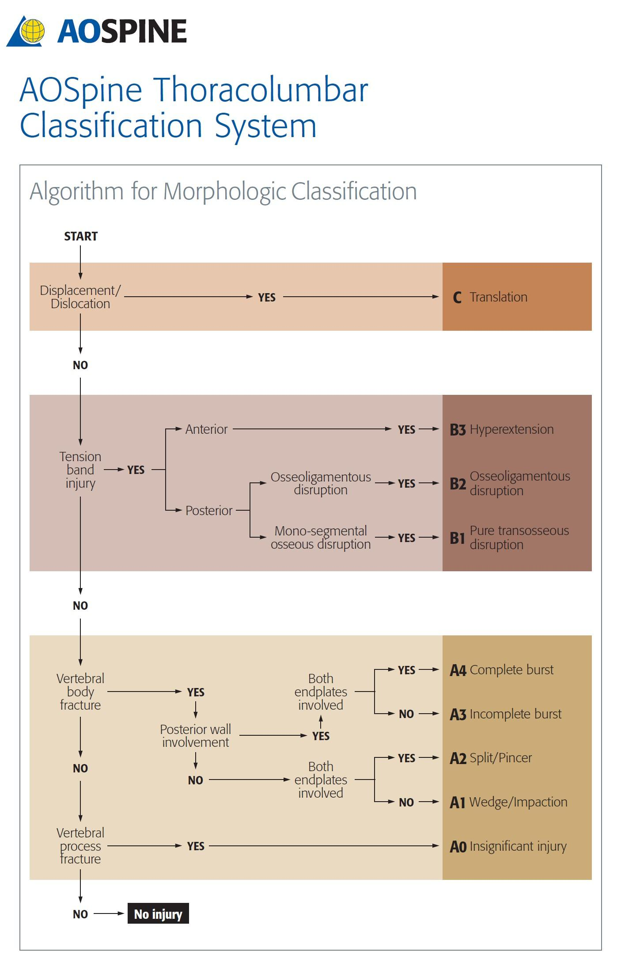

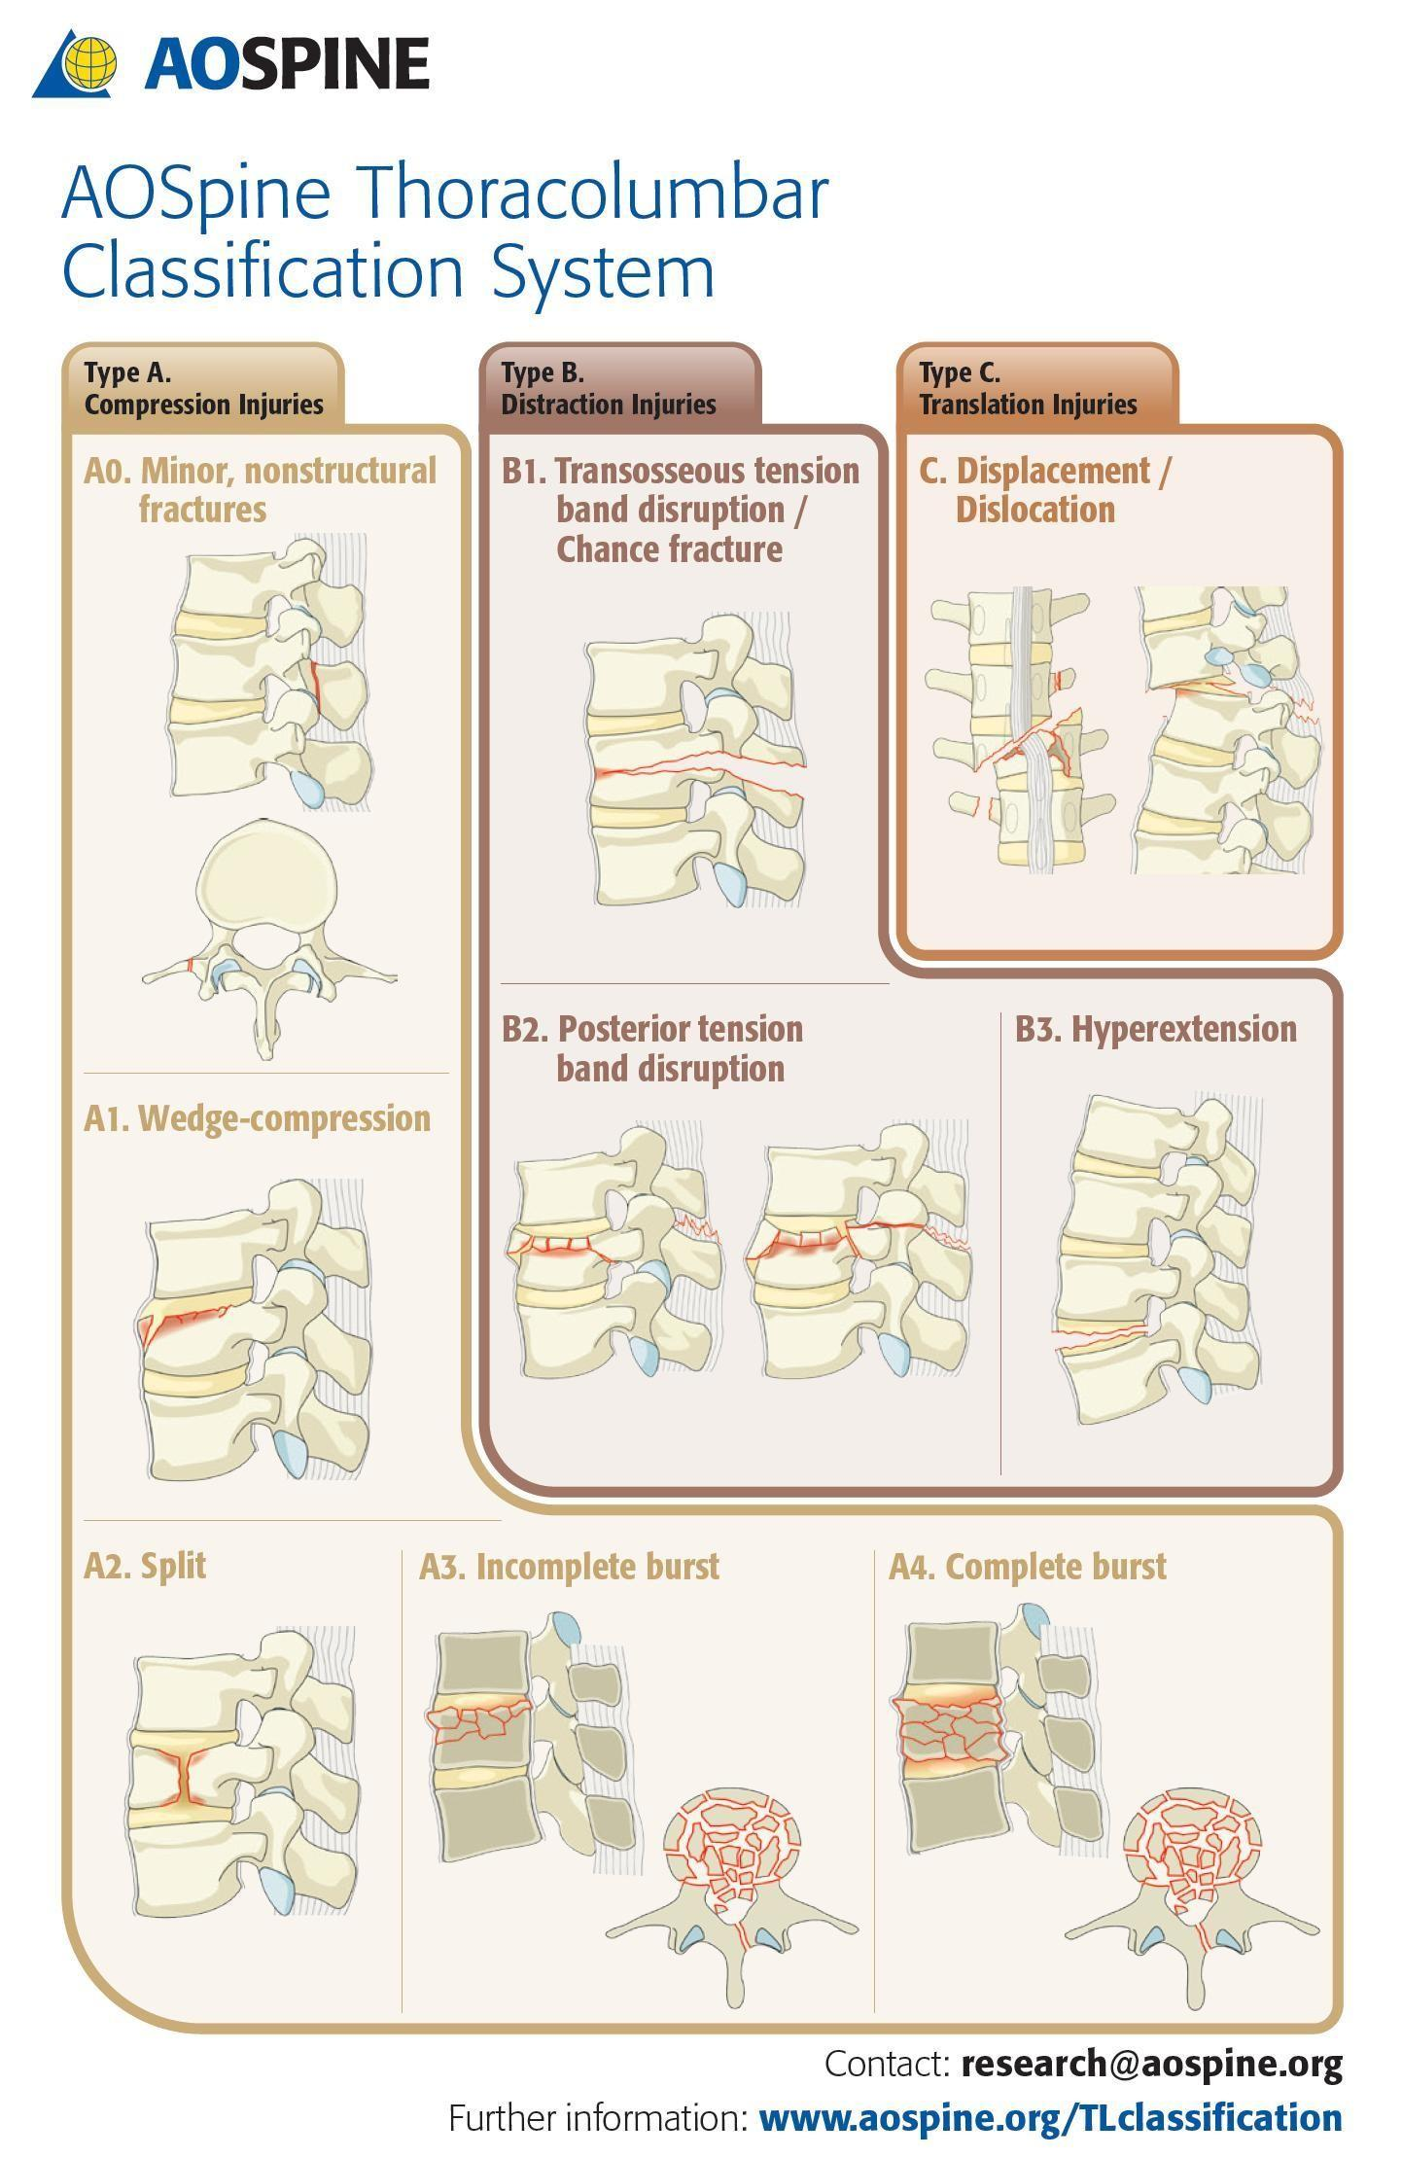

# NHS GGC ACUTE SPINAL TRAUMA PROTOCOL

For patients presenting to an Emergency Department within NHSGGC with Acute Spinal Trauma:

Referral is to the local Orthopaedic team from the Emergency Department. Appropriate cases should be referred and admitted to the local Orthopaedic team with further discussion and advice as below:

* **Cervical Spine Injury – with neurological deficit**: Admission will most likely be to HDU under the care of Orthopaedics but Orthopaedics will also discuss immediately with the National Spinal Injuries team on-call for advice, with transfer* to National Spinal Injuries Unit as appropriate

*Where transfer is not appropriate then written advice will be made available through clinical portal.

* **Cervical Spine Injury – no neurological deficit:** Orthopaedic team to discuss with neurosurgical team on-call who will provide definitive, patient specific management advice** with transfer for Neurosurgical intervention as required

**Advice will be written and made available on clinical portal within 24 hours or (by Monday for those patients admitted at the weekend if there is no spinal neurosurgeon on call).

Where follow up is to be provided through the local Orthopaedic team the neurosurgical advice will be available on the front page of clinical portal (patient notes) and will provide guidance on: immediate management advice, imaging advice and the timing of this, guidance on when to refer back to neurosurgery for further input and follow up advice 

* + **Thoracolumbar Spine Injury – with neurological deficit:** Admission will most likely be to HDU under the care of Orthopaedics but Orthopaedics will alsodiscuss immediately with the National Spinal Injuries team on-call for advice, with transfer* to NationalSpinal Injuries Unit as appropriate

*Where transfer is not appropriate then written advice will be made available through clinical portal.

* + **Thoracolumbar Spine Injury – no neurological deficit:** Discuss with Ortho-spinal team via email proforma and call to QEUH registrar on-call. Ortho-spinal team will providedefinitive, patient specific management advice**.

**Advice will be written and made available on clinical portal within 24 hours or by Monday for those patients admitted at the weekend if there is no ortho-spinal surgeon on call.

**OTHER PATIENTS APPROPRIATE FOR ORTHO SPINE REFERRAL**

* + Chronic radicular pain resistant to conservative management
  + Radicular pain with subtle motor loss
  + Back pain and red flags for malignancy but no suspicion of cord compression/CES

Patients whose only symptom is back pain in the absence of red flags are not to be referred to the spinal fracture clinic.

The referral routes for a spinal opinion on patients who do not require admission or urgent investigation are:

Acute advice via the on-call registrar who will put it on the Bluespier list and present it the

following day if there is a spinal consultant on trauma week.

If no spinal consultant on trauma week, then a group email to all the spinal consultants with

the attached spinal trauma proforma.

Advice on follow-up for scan results etc. is a referral email sent to: [**wgach.orthopaedicspinalreferrals@ggc.scot.nhs.uk**](mailto:wgach.orthopaedicspinalreferrals@ggc.scot.nhs.uk), which will allow it to be put on our vetting system and tracked.

All patients referred to the on-call team and seen in ED with a spinal complaint should be given one of the CES advice leaflets prior to D/C. It should be documented in the notes that this has been administered. It is on StaffNet in NHSGGC (reference number 282539) in a range of languages. This is to reduce the risk of medicolegal issues should the patient develop CES after they have been D/C from ED.